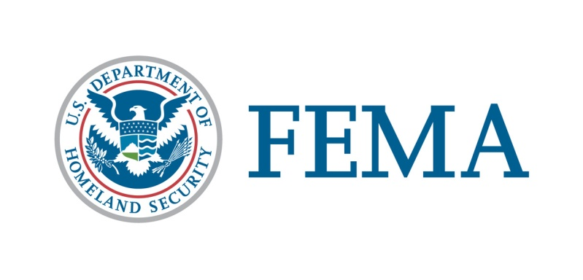

##### Congressional Affairs Division

202-646-4500

**State of Maine**

**Federal Disaster Declaration Fact Sheet**

**March 20, 2024**

Today, March 20, 2024, President Joseph R. Biden Jr., granted a Major Disaster Declaration for the State of Maine triggering the release of Federal funds to help individuals and communities recover from Severe Storms and Flooding that occurred January 9-13, 2024. Details of the disaster declaration and assistance programs are as follows:

Declaration Number: FEMA-4764-DR

Incident: Severe Storms and Flooding

Incident Period: January 9-13, 2024

Federal Coordinating Officer: Robert V. Fogel

National FCO Program

Individual Assistance (IA): (Assistance to individuals and households):

IA-Designated Counties: Cumberland, Hancock, Knox, Lincoln, Sagadahoc, Waldo, Washington, and York Counties.

Public Assistance (PA): (Assistance for emergency work and the repair or replacement of disaster-damaged facilities):

PA-Designated Counties: Cumberland, Hancock, Knox, Lincoln, Sagadahoc, Waldo, Washington, and York Counties.

Hazard Mitigation (HM): (Assistance for actions taken to

prevent or reduce long term risk to

life and property from natural

hazards):

HM-Designated Areas: All areas in the State of Maine are eligible to apply for assistance under the Hazard Mitigation Grant Program.

OTHER: additional designations may be made at a later date if requested by the state and warranted by the results

of further damage assessments.

Individuals in Cumberland, Hancock, Knox, Lincoln, Sagadahoc, Waldo, Washington, and York Counties can apply with FEMA the following ways:

1. Apply online at [www.DisasterAssistance.gov](http://www.DisasterAssistance.gov).
2. Constituents may call the application phone number at 1-800-621-3362 (TTY: 800-462-7585).

###